History

Press the "Prepared!" to add a recipe to the preparation history. The date of the last preparation is displayed in the recipe list. The preparation history lists all prepared dishes chronological order. Initially, the last 30 dishes are displayed. If you want to look further into the past, press the button "More..." at the end of the recipe list.

The history also allows you to filter the recipes by category:

|  |  |
| --- | --- |
|  | Set filter |
|  | Delete filter |

# Add an external recipe

If you have prepared a recipe that is not your stored in your collection, you can still record it in the history.

To do this, press the button:



This opens a dialog box where you can enter the details of the recipe:

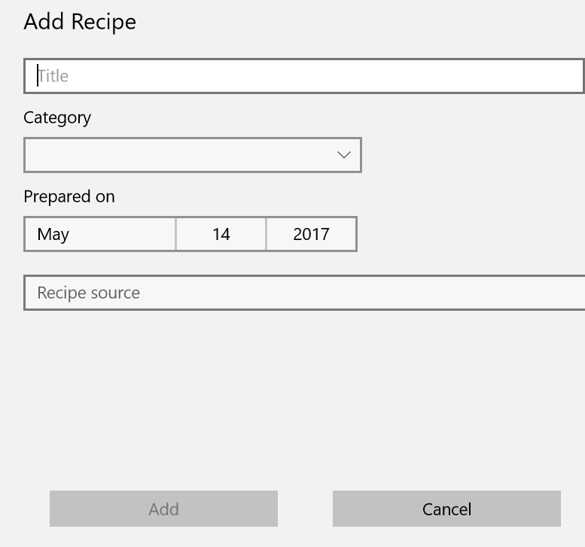

# Exporting and importing the history

If you use the program on multiple computers, the history is not automatically synchronized (in contrast to the favorites). You can however export the history to a file, and then import it again on another device.

